Huỳnh Văn Đường

MSSV: 18058281

Lab3

Bài2

*Code

*Myserver

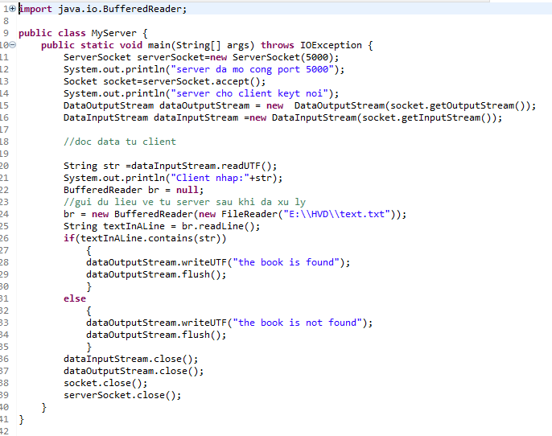

*Myclient

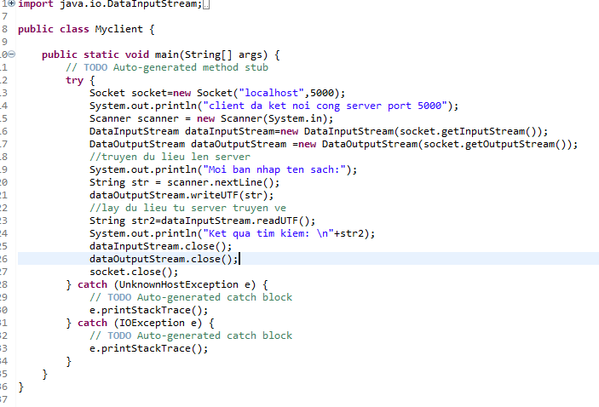

Kết quả:

*Myserver

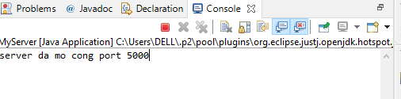

*Myclient

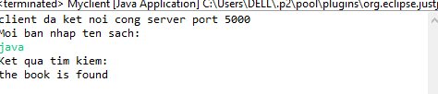

**Bài5**

*Code

*Myserver

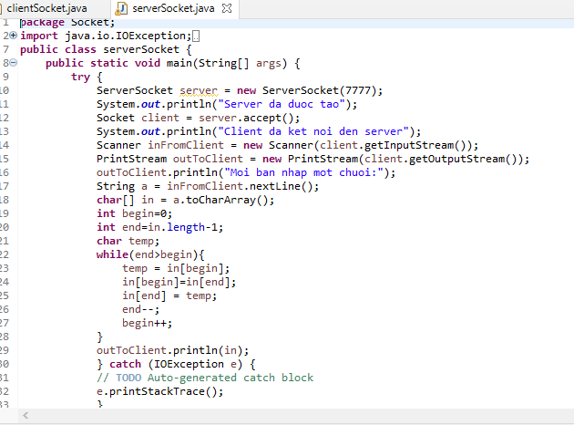

*Myclient

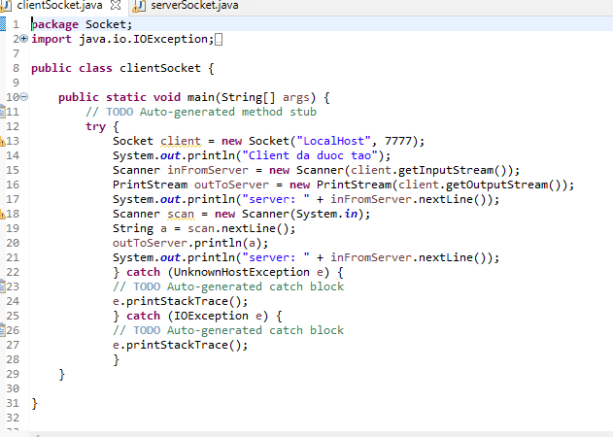

**Kết quả:**

**\*Myserver**



*Myclient

